Western Dubuque
Fine Arts Booster Club

Types of memberships:

_____ Fine Arts Monetary donation
$_______________

_____ Single Membership | $50
Name: ____________________________

_____ Dual Membership | $75
Names: ____________________________

_____ Family Membership | $100
(Husband/Wife and children 18 and under.
Must reside in the same household.)
Names: ___________________________
_____________________________
_____________________________

Membership:
Check by Mail:
WDHS Fine Arts Booster Club
P.O. Box 379
Epworth, IA 52045

Revtrak: Scan QR code for link
Board Members:
Jenny Hillebrand- President
Sara Phillips-Vice President
Becky Coyle– Treasurer
Tara Streif - Secretary
Tyler Lown - Activities Director
Michael Omarzu - Band Director
Christine Tipple - Vocal Music Director
Brian Phillips
Brian Jones
Heather Hermsen
Mick Hermsen

We are always looking for more members to join us in supporting Western Dubuque Fine Arts. Please reach out to us at: WDfinearts@gmail.com
Meetings are 1 hour and hosted at Western Dubuque High School.

Western Dubuque
Fine Arts Booster
2023-2024

Recent fine arts contributions to the various Western Dubuque Fine Arts Departments:

- Drum Set, mellophones
- Clavinova Piano
- Kiln
- Show Choir Risers
- Auditorium ear set/microphones
- Show band mixing board
- Band PA system
- Pop up tents
- Dance Team Uniforms for Nationals
- Drama entry fee/scrips
- Yearly Auditorium technical enhancements
- Props and Costumes for plays and performances
- Service Day Shirts
- Student requests
- Fine Arts College Scholarships
- Summer Fine Arts programs

We are only able to fund these through memberships, contributions and our annual Wingfest fundraiser in September.

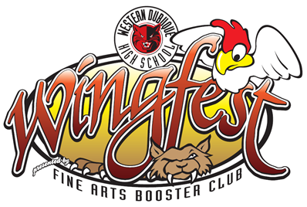
Fine Arts membership gives you admission to following at no additional cost to you:

- Fall Marching Band Concert
- Halloween Hoot
- Fall Chamber Choir Musical (all showings)
- Fall Play (all showings)
- Band Holiday Concert
- Choir Cocoa’s & Carols
- Choir/Winter Concert
- Show Choir Main Event
- Band Spring Concert
- Band Jazz Night
- Band Solo Ensemble Night
- Spring Musical (all showings)
- Band Fusion concert
- Band Homecoming Concert
- Choir Pops Concert
Cost is normally $5-$10 a person per event

Contact Information
Name:
____________________________
Address:
________________________________________________________
Email Address:
____________________________
Phone Number:
____________________________

On behalf of the Western Dubuque Fine Arts Booster Club and the students:

Thank you for your support!

